Hands-on Lab: ES6 Features with React (Cricket App)
Topic: ES6 let/const, classes, arrow functions, map/filter, destructuring

Objectives
- List the features of ES6
- Explain JavaScript let
- Identify the differences between var and let
- Explain JavaScript const
- Explain ES6 class fundamentals
- Explain ES6 class inheritance
- Define ES6 arrow functions
- Identify set(), map()

What You Will Learn
- Use the map() method of ES6
- Apply arrow functions of ES6
- Implement destructuring features of ES6

Prerequisites
- Node.js
- NPM
- Visual Studio Code

ES6 Concepts — Quick Reference
- let: block-scoped variable declaration; can be reassigned but not redeclared in the same scope.
- var vs let: var is function-scoped and hoisted (usable before declaration, initialized as undefined); let is block-scoped and stays in a "temporal dead zone" until its declaration line, which prevents many accidental-reuse bugs.
- const: block-scoped binding that cannot be reassigned after initialization; object/array contents referenced by a const can still be mutated.
- class: syntactic sugar over JavaScript's prototype-based inheritance, defined with the class keyword, a constructor(), and methods without the function keyword.
- class inheritance: a subclass uses extends to inherit from a parent class and super() inside its constructor to call the parent constructor.
- Arrow functions: a shorter function syntax (params) => expression that does not bind its own this, making it convenient inside class methods and array callbacks.
- map(): built-in Array method that returns a new array by transforming every element with a callback — used here to render players and merge lists.
- Set(): a built-in collection that stores only unique values, useful for de-duplicating arrays.

Application: cricketapp
A React application named cricketapp was created with two components, ListofPlayers and IndianPlayers, which are toggled on the home page using a simple flag variable.

1. ListofPlayers Component
- Declared an array of 11 players, each with a name and score, and rendered them using the ES6 map() method.
- Filtered the players with a score below 70 using an ES6 arrow function passed to filter().
// src/components/ListOfPlayers.js
import React from 'react';

const players = [
{ name: 'Rohit Sharma', score: 85 },
{ name: 'Virat Kohli', score: 92 },
{ name: 'Shubman Gill', score: 45 },
{ name: 'KL Rahul', score: 60 },
{ name: 'Suryakumar Yadav', score: 78 },
{ name: 'Hardik Pandya', score: 55 },
{ name: 'Ravindra Jadeja', score: 40 },
{ name: 'Axar Patel', score: 65 },
{ name: 'Kuldeep Yadav', score: 30 },
{ name: 'Mohammed Shami', score: 20 },
{ name: 'Jasprit Bumrah', score: 25 },
];

function ListOfPlayers() {
// ES6 map() to render every player
// ES6 arrow function + filter() to get players scoring below 70
const belowSeventy = players.filter((player) => player.score < 70);

return (
<div>
<h2>All Players</h2>
<ul>
{players.map((player, index) => (
<li key={index}>{player.name} - {player.score}</li>
))}
</ul>

<h2>Players with Score Below 70</h2>
<ul>
{belowSeventy.map((player, index) => (
<li key={index}>{player.name} - {player.score}</li>
))}
</ul>
</div>
);
}

export default ListOfPlayers;

2. IndianPlayers Component
- (a) Split the Odd Team and Even Team player arrays into individual names using ES6 array destructuring (including the rest pattern).
- (b) Declared T20players and RanjiTrophyPlayers arrays and merged them using the ES6 spread operator, then displayed the combined list.
// src/components/IndianPlayers.js
import React from 'react';

const oddTeam = ['Rohit Sharma', 'Shubman Gill', 'Suryakumar Yadav',
'Ravindra Jadeja', 'Kuldeep Yadav', 'Jasprit Bumrah'];
const evenTeam = ['Virat Kohli', 'KL Rahul', 'Hardik Pandya',
'Axar Patel', 'Mohammed Shami'];

const T20players = ['Rohit Sharma', 'Virat Kohli', 'Hardik Pandya'];
const RanjiTrophyPlayers = ['Prithvi Shaw', 'Sarfaraz Khan', 'Yash Dhull'];

function IndianPlayers() {
// ES6 array destructuring
const [oddPlayer1, oddPlayer2, ...restOdd] = oddTeam;
const [evenPlayer1, evenPlayer2, ...restEven] = evenTeam;

// ES6 spread operator to merge two arrays
const allPlayers = [...T20players, ...RanjiTrophyPlayers];

return (
<div>
<h2>Odd Team Players</h2>
<p>{oddPlayer1}, {oddPlayer2}, {restOdd.join(', ')}</p>

<h2>Even Team Players</h2>
<p>{evenPlayer1}, {evenPlayer2}, {restEven.join(', ')}</p>

<h2>T20 + Ranji Trophy Players (Merged)</h2>
<ul>
{allPlayers.map((name, index) => (
<li key={index}>{name}</li>
))}
</ul>
</div>
);
}

export default IndianPlayers;

3. Toggling Components with a Flag
Both components are rendered from App.js. A boolean flag variable decides, through a simple conditional (ternary) expression, which component is shown on the home page.
// src/App.js
import React from 'react';
import ListOfPlayers from './components/ListOfPlayers';
import IndianPlayers from './components/IndianPlayers';
import './App.css';

const flag = true; // set to false to render IndianPlayers instead

function App() {
return (
<div className="App">
<h1>Cricket App</h1>
{flag ? <ListOfPlayers /> : <IndianPlayers />}
</div>
);
}

export default App;

Output

When flag = true (ListofPlayers is rendered)
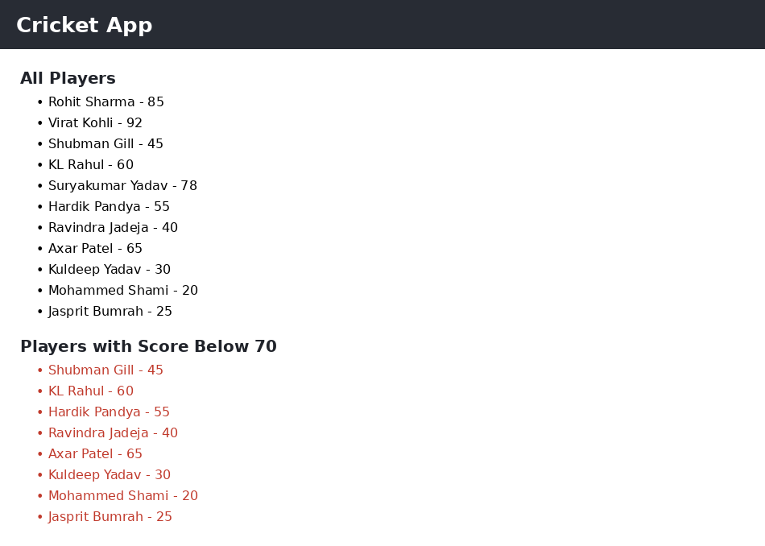

When flag = false (IndianPlayers is rendered)
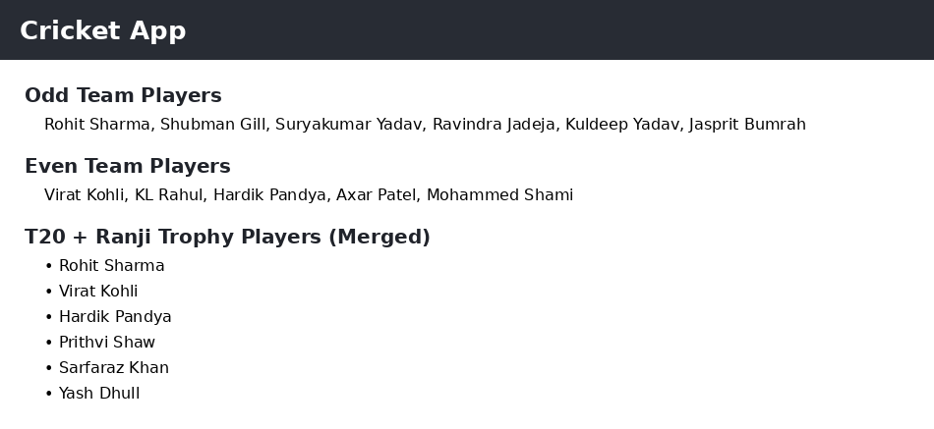

Conclusion
This lab applied several ES6 features inside a React application: array map() and arrow functions to render and filter the player list, array destructuring (with the rest pattern) to split team arrays into individual values, and the spread operator to merge two arrays. A simple boolean flag combined with a ternary expression was used to switch between the two components on the same home page, demonstrating how ES6 syntax makes component logic in React more concise and readable.

